Birla Institute of Technology & Science, Pilani
Work Integrated Learning Programmes Division
Second Semester 2023-2024

Comprehensive Test
(EC-3 Makeup ANSWER-KEY)

Course No. : CCZG556
Course Title : Stream Processing and Analytics
Nature of Exam : Open Book
Weightage : 40%
No. of Pages = 6

No. of Questions = 4
Duration : 2 Hours
Date of Exam : 06/03/2021 or 19/03/2021 (FN/AN)
Note to Students:
- Please follow all the Instructions to Candidates given on the cover page of the answer book.
- All parts of a question should be answered consecutively. Each answer should start from a fresh page.
- Assumptions made if any, should be stated clearly at the beginning of your answer.

Q1. Consider the following block diagram representing the Spark Streaming context. Using the information shown in the diagram answer the question given below:
[1 + 2 + 1 + 1 + 1 + 1 + 1 + 2 = 10]

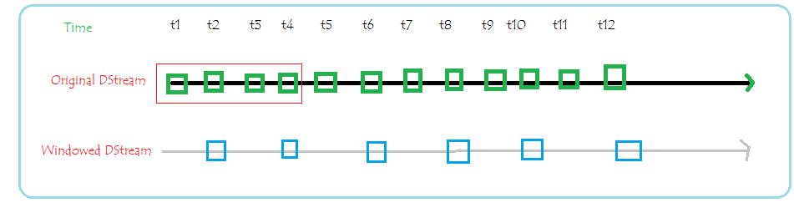

- What is the batch interval specified?
- What is the window length and slide interval specified?
- Do you see any discrepancy between batch and slide interval?
- How many times the windowed operation will be executed?
- What Dstreams will be considered when third windowing operation invocation will happen?
- If each of the DStream contains exactly 4 events in it, then at time of execution of fourth windowing operation, how many events will be processed?
- If the batch interval is changed to 2 time units, what changes needs to be done in the window length and sliding interval?
- Show a similar representation of Spark Streaming context if batch interval is 2 time units, window interval is 6 time units and sliding interval 2 time units?

Answer:
- Batch interval = 1 time unit = DStream length
- Window length = 4 time unit, Sliding interval = 2 time units
- No, both window length and sliding intervals are multiple of batch interval
- 6 times - at every slide of window
- DStream at t3, t4, t5 and t6
- 16 – 4 from each of DStream t8, t7, t6 and t5
- No change, as still sliding interval and window length are multiple of batch interval
- Batch interval – 2 time units
Window length – 6 time units
Sliding interval – 2 time units
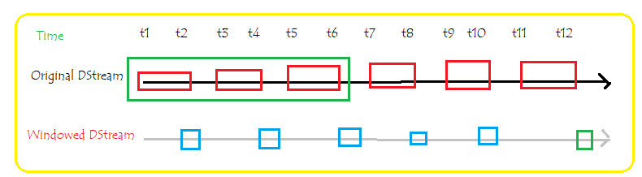
Q2. Assume that you need to count how many times an article is read – article is represented with a number like article 1 as 1, article 2 as 2 and so on. Employ a 4-column, 4-row Count-Min Sketch for this exercise. The hash functions are as follows
Hash1 = (input * 2 + 1) mod 3
Hash2 = (input * 3 - 1) mod 4
Hash3 = (input * 3 + 1) mod 5
Hash4 = (input * 2 - 1) mod 6

The articles are read in sequence 2, 3, 3, 8, 2, 3, 8.
- For each of the input show the state of Count-Min sketch with all relevant computations. [8]
- Per the Count-Min sketch how many times the article 8 is read? [2]
Answer:
- For each of the input show the state of Count-Min sketch with all relevant computations. [8]
Count-Min Sketch will look like – 1 mark for initial sketch

Hash1 | Hash2 | Hash3 | Hash4
0 | 0 | 0 | 0
0 | 0 | 0 | 0
0 | 0 | 0 | 0
0 | 0 | 0 | 0

Then for each input value
Hash values calculation -0.5 mark
Table representation for – 0.5 mark
Input = 2
Hash1 = (input * 2 + 1) mod 3 = ( 2 * 2 + 1 ) mod 3 = 2
Hash2 = (input * 3 - 1) mod 4 = ( 2 * 3 - 1 ) mod 4 = 1
Hash3 = (input * 3 + 1) mod 5 = ( 2 * 3 + 1 ) mod 5 = 2
Hash4 = (input * 2 - 1) mod 6 = ( 2 * 2 - 1 ) mod 6 = 3

Hash1 | Hash2 | Hash3 | Hash4
0 | 1 | 0 | 0
1 | 0 | 1 | 0
0 | 0 | 0 | 1
0 | 0 | 0 | 0

Input = 3
Hash1 = (input * 2 + 1) mod 3 = ( 3 * 2 + 1 ) mod 3 = 1
Hash2 = (input * 3 - 1) mod 4 = ( 3 * 3 - 1 ) mod 4 = 0
Hash3 = (input * 3 + 1) mod 5 = ( 3 * 3 + 1 ) mod 5 = 0
Hash4 = (input * 2 - 1) mod 6 = ( 3 * 2 - 1 ) mod 6 = 5

Hash1 | Hash2 | Hash3 | Hash4
1 | 1 | 0 | 0
1 | 0 | 1 | 0
0 | 0 | 0 | 1
0 | 0 | 0 | 0

Input = 3
Hash1 = (input * 2 + 1) mod 3 = ( 3 * 2 + 1 ) mod 3 = 1
Hash2 = (input * 3 - 1) mod 4 = ( 3 * 3 - 1 ) mod 4 = 0
Hash3 = (input * 3 + 1) mod 5 = ( 3 * 3 + 1 ) mod 5 = 0
Hash4 = (input * 2 - 1) mod 6 = ( 3 * 2 - 1 ) mod 6 = 5

Hash1 | Hash2 | Hash3 | Hash4
2 | 1 | 0 | 0
1 | 0 | 1 | 0
0 | 0 | 0 | 1
0 | 0 | 0 | 0

Input = 8
Hash1 = (input * 2 + 1) mod 3 = ( 8 * 2 + 1 ) mod 3 = 2
Hash2 = (input * 3 - 1) mod 4 = ( 8 * 3 - 1 ) mod 4 = 3
Hash3 = (input * 3 + 1) mod 5 = ( 8 * 3 + 1 ) mod 5 = 0
Hash4 = (input * 2 - 1) mod 6 = ( 8 * 2 - 1 ) mod 6 = 3

Hash1 | Hash2 | Hash3 | Hash4
2 | 1 | 0 | 0
2 | 0 | 1 | 0
0 | 1 | 0 | 2
0 | 0 | 0 | 0

Input = 2
Hash1 = (input * 2 + 1) mod 3 = ( 2 * 2 + 1 ) mod 3 = 2
Hash2 = (input * 3 - 1) mod 4 = ( 2 * 3 - 1 ) mod 4 = 1
Hash3 = (input * 3 + 1) mod 5 = ( 2 * 3 + 1 ) mod 5 = 2
Hash4 = (input * 2 - 1) mod 6 = ( 2 * 2 - 1 ) mod 6 = 3

Hash1 | Hash2 | Hash3 | Hash4
2 | 2 | 0 | 0
3 | 0 | 2 | 0
0 | 1 | 0 | 3
0 | 0 | 0 | 0

Input = 3
Hash1 = (input * 2 + 1) mod 3 = ( 3 * 2 + 1 ) mod 3 = 1
Hash2 = (input * 3 - 1) mod 4 = ( 3 * 3 - 1 ) mod 4 = 0
Hash3 = (input * 3 + 1) mod 5 = ( 3 * 3 + 1 ) mod 5 = 0
Hash4 = (input * 2 - 1) mod 6 = ( 3 * 2 - 1 ) mod 6 = 5

Hash1 | Hash2 | Hash3 | Hash4
3 | 2 | 0 | 0
3 | 0 | 2 | 0
0 | 1 | 0 | 3
0 | 0 | 0 | 0

Input = 8
Hash1 = (input * 2 + 1) mod 3 = ( 8 * 2 + 1 ) mod 3 = 2
Hash2 = (input * 3 - 1) mod 4 = ( 8 * 3 - 1 ) mod 4 = 3
Hash3 = (input * 3 + 1) mod 5 = ( 8 * 3 + 1 ) mod 5 = 0
Hash4 = (input * 2 - 1) mod 6 = ( 8 * 2 - 1 ) mod 6 = 3

Hash1 | Hash2 | Hash3 | Hash4
3 | 2 | 0 | 0
4 | 0 | 2 | 0
0 | 2 | 0 | 4
0 | 0 | 0 | 0

- Per the Count-Min sketch how many times the article 8 is read? [2]
Answer:
Input = 8
Hash1 = (input * 2 + 1) mod 3 = ( 8 * 2 + 1 ) mod 3 = 2
Hash2 = (input * 3 - 1) mod 4 = ( 8 * 3 - 1 ) mod 4 = 3
Hash3 = (input * 3 + 1) mod 5 = ( 8 * 3 + 1 ) mod 5 = 0
Hash4 = (input * 2 - 1) mod 6 = ( 8 * 2 - 1 ) mod 6 = 3

Examine content at (2,1), (3,2), (0,3) and (3,4) i.e. 4, 2, NA, 4.
Min {4, 2, NA, 4 } = 2
Article 8 is read two times.

Q3. Stream X1 has attributes “b” and “id”. Stream Y1 has attributes “a” and “id”. The two streams are joined based on “id” attribute. Time is progressing from left to right direction. The streaming query is defined as follows -

Select a + b, a – b,
From X1 as x1 join Y1 as y1
on x1.id = y1.id

Replace the “?” shown in the following figure using the above mentioned information. [10]

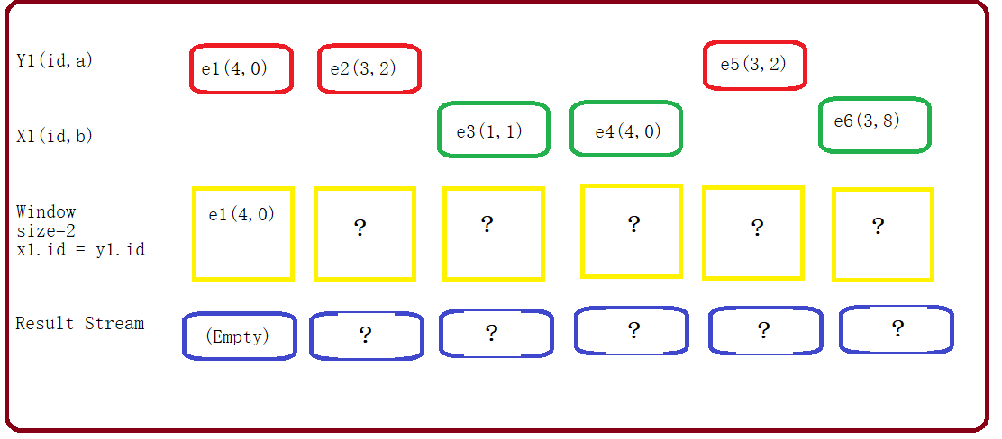

Answer:
Q4. Consider the following stream of events coming from a truck. Periodically these events are received and processed on the server side for doing some rum time analytics as shown in the query below.

Event Stream data

Truck_ID | EventTime | Status | Qty
T1 | 11.20 | Running | 200
T2 | 11.15 | Running | 300
T3 | 11.09 | Running | 100
T1 | 11.50 | Running | 200
T2 | 11.45 | Running | 300
T3 | 11.39 | Broken | 100
T4 | 11.19 | Running | 200
T1 | 12.20 | Running | 200
T2 | 12.15 | Running | 300
T3 | 12.09 | Broken | 100
T4 | 11.49 | Running | 200
T1 | 12.50 | Broken | 200
T2 | 12.45 | Running | 300
T3 | 12.39 | Running | 100
T4 | 12.37 | Running | 200

The structured streaming Query –
inputDataFrame.groupBy(Status).window(60 minutes).sum(Qty)

Showcase the content of following tables when the query is executed at 12.00 and 1.00 PM respectively. [10]
- Input table
- Result table
- Output when mode is respectively
  - Complete
  - Update
  - Append

Answer:

*********************************

